

23CSIS01I

Systems Analysis and Design

# Phase III Report

# Mystery Purse

### **Team Members:**

|  |  |  |
| --- | --- | --- |
| ID | Name | Email |
|  | Abdelrahman |  |
|  | Amr |  |
|  | Sameh |  |

Table of Contents

1. **Game Overview 1**
   1. Game genre1
   2. Target Audience1
2. **Dramatic elements of the game 1**
   1. Characters6
   2. Boundaries6
   3. Detailed Story7
3. **Formal Elements 9**
   1. Mechanics9
      1. Player interaction pattern 9
      2. Goals9
      3. Rules 9
      4. Actions and Interactions11
      5. Challenges18
      6. Resources 19
      7. Player Mode Sketches 20
      8. Audio 25
      9. Outcome 25
4. **Dynamic Elements 25**
   1. Sequence Of Events 25
   2. Behavior And Relationships 27
   3. Objectives Of Each Level 28
   4. Cut Scenes 29
   5. Guidance 30
5. **Game Overview**
   1. **Game Genre**: Adventure, RPG
   2. **Target Audience**: Males & Females above Age 10 in all countries.
6. **Dramatic elements of the game**

**2.1 Characters**: Detailed description of the game characters (playing and NPC), personality, appearance, and, abilities

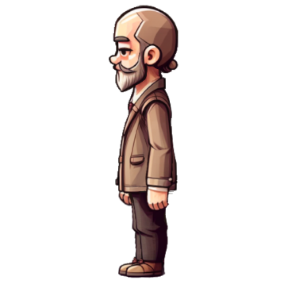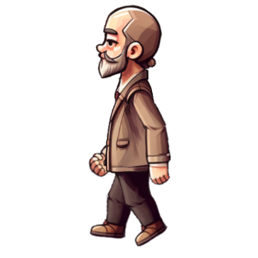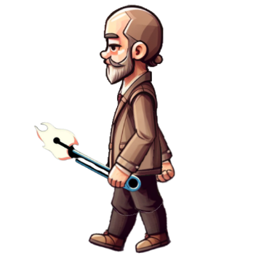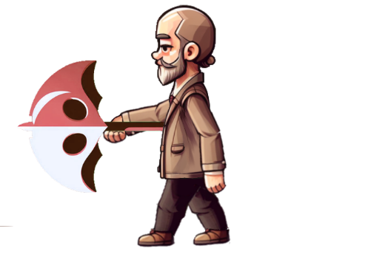

**Taimor:**

Taimor is a grumpy old man in his late 50s who has white hair and tends to always wear boring beige clothing like he it is the 1960’s all over again. Taimor banters a lot and mutters his complains in silence. He has two special abilities inside the purse: he could summon a safety pin and fight enemies with it, and he can unfold an entire umbrella that acts as shield.

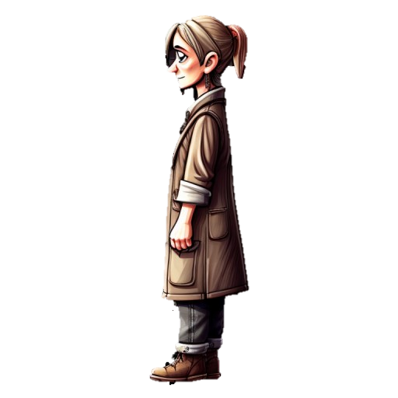

**Shafika:**

Shafika was once a talented freelance illustrator as a young woman turned housewife of thirty years that has become a source of daily complains in her husband’s life. Due to mysterious circumstances, Shafika’s marriage, once filled with love and laughter, transformed into a never-ending soap opera of daily complaints.

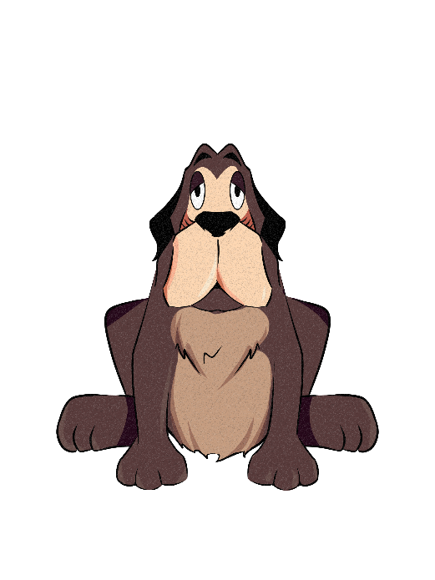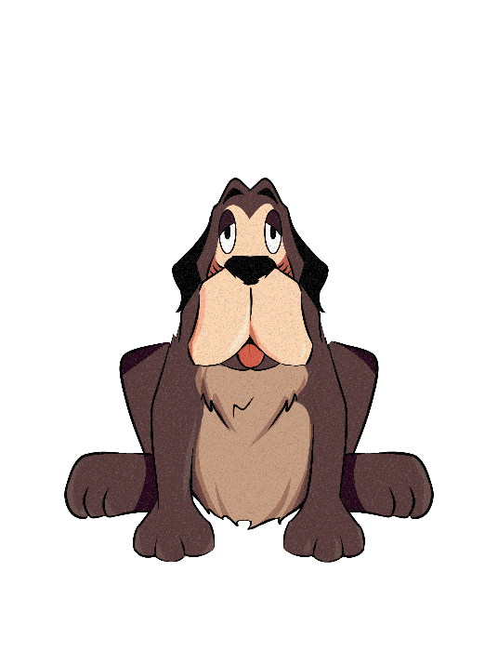

**Metwaly the dog:**

Metwaly has been part of Taimor and Shafiqa’s life for so long he both looks and sounds just like them in his dog form. He is a large brown dog with lighter inner fur. Inside the purse, he is sarcastic and tends to be just as demanding if not more demanding than Shafiqa with his requests from Taimor. His special abilities could simply be the ability to speak and guide begrudgingly through the levels to help him escape.

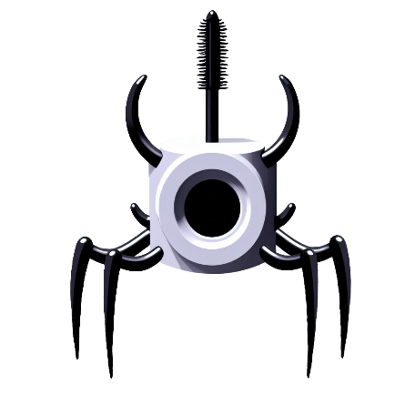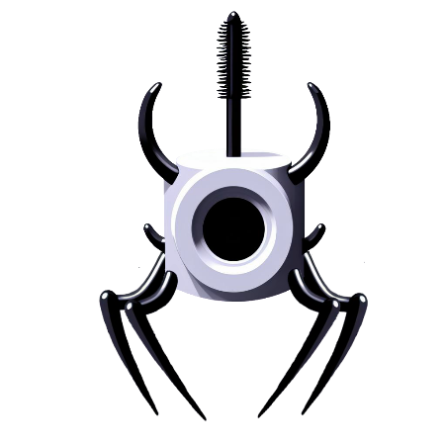

**Mascara:**

Mascara is the enemy chasing Taymor (the main character) in level one, mascara appears behind Taimor from the first second in level one so it will be close to Taimor’s start position, mascara movement was designed to simulate sea crab movement by animating its four legs together and making it move horizontally only on the X-axis, and its movement is just on the ground and it cannot fly anymore. When mascara hits Taymor it causes damage equal to 1/3 of Taymor’s total health which means that Taymor will be destroyed after 3 times mascara hits, mascara cannot change (increase/decrease) its speed, mascara can boost its health after taking a hit from Taimor by using mascara’s health drink.

There is a lot of mascara enemy in level one, mascara starts to chase Taymor from the beginning of the level till the end, Taymor will always try to destroy all Mascara enemies in order to move throughout the level structure and collect the hints that will help to solve the puzzle in order to finally pass level one.

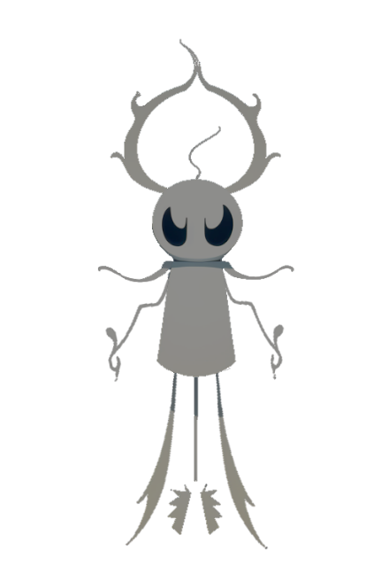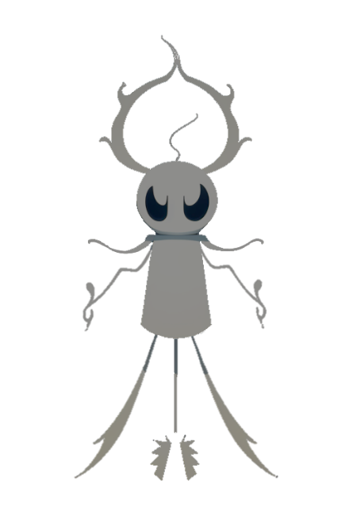

**Ghost Pin:**

Pins in general have a reputation of being lost in broad day light, imagine how much worse it is when they're lost inside a woman's purse? This is how "Lost Pin" became "Ghost Pin." Ghost Pin has the ability to fly as it's often asked "where did the pin go? It's not like it flew away." Ghost Pin holds a grudge against the world he was trapped in and haunts whoever enters the territory it assigned itself since then. It also has the creatively named "Ghost Ability" of being able to go through walls and floats anywhere it wants and chasing the main character without being affected by his attacks and defenses.

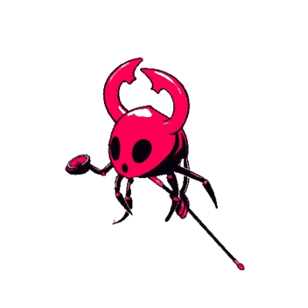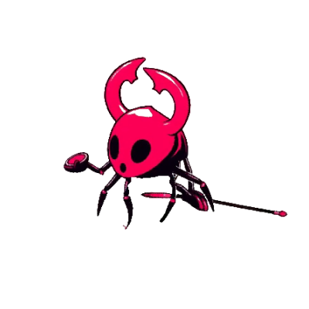

**Rouge:**

Rouges are designed to make the people look more beautiful. But since this horrific crisis of where Taimor has been stuck inside the purse, Rouges have turned into monstrous evil enemies like no other. This rouge enemy has 4 legs like any harm insect. On top of that it has a very dangerous weapon that it uses to harm anything on its way. Not only does it do a lot of damages to anything but also it has the ability to move very fast which makes it more extremely difficult to face.

**2.2 Boundaries**:

The main setting of the game takes place inside Shafiqa’s purse with each level symbolizing “memories” between the grumpy couple within the domain of the magical purse itself.

**Level 1**

The setting is composed of dates and Shafiqa’s preferences such as her favorite dish, color, animal, clothing brand etc.

**Level 2**

The setting composes of the places where their married life began as a couple which is a mishmash of their first house, early furniture, and the tree where Taimor first proposed to Shafiqa.

**Level 3**

This setting consists of all of the places that they have visited in their honeymoon. On top of that these places have is remarked to be their one of the best places they have visited because of the many memories they have left there while they were in the vacation together.

**Level 4**

The setting of the final level is where all the issues began in their marriage: his mother-in-law’s house.

**2.3 Detailed Story**:

Taimor, a weary husband, returns home from a long day at work. He joins his wife, Shafika, for dinner who is all smiling for some reason. He eats his food in silence as usual, and that’s when his wife proceeds to bombard him with numerous requests never-ending complaints. “What is it with you today? You’re complaining a lot” he asks calmly. “Well, how is it different from any day?” she replies sarcastically. He replies “you’re complaining more than usual, that’s the point.” That’s when she loses it and complains even more about how he never acknowledges her and only cares about his food and belly. Exhausted, as soon as she requests that he retrieves something from her purse, he hurries to leave her sight and have some quiet time. As he approaches her purse wearingly, he opens the purse and sticks his hand to find the item. That’s when an unexpected and bizarre event occurs. Taimor is inexplicably swallowed into the depths of the purse, encountering a surreal world filled with obstacles and adversaries—each one representing a unique item from within the purse. He soon finds himself in the purse’s lowest level, where he discovers a picture of his beloved dog. This picture becomes his guiding light as he embarks on a perilous journey, ascending through the various levels (pockets) of the purse. What was going to be another mundane afternoon turned into an escape missing as Taimor must confront an array of foes, all composed of the weird and crazy items that dwell within his wife’s purse.

Taimor wakes up in a panic, with mascara choking him in an attempt to kill him. Taimor flees until he finds his dog, Metwaly, who assumes the role of being his guide and begins to lead him to where the boxes are that he wants to open. Taimor searches for the boxes and encounters numerous enemies. Unable to defeat them all at once, Taimor must devise a plan to destroy the enemies. He begins by fighting each one individually before lighting a fire to burn the other enemies. Once the fire is lit, the player cannot put it out because it is so large, so Taimor moves to the second row to use the trampoline to allow him to take a long jump to reach the fourth row directly. Then, he proceeds to move to the third row to open the box and read its content. Taimor then starts to move to the fourth row to a repository that contains the health drinks to boost his health. Suddenly, the player will find a new enemy that is trying to kill Taimor, so he has to kill him or escape. Finally, the player reaches the fifth row to find the wise statue. The wise statue starts to give the player a puzzle that the player must think to solve by using the hints that he collected later from the boxes so the player starts to solve. If he answers the puzzle correctly, the player will pass to level two.

After ascending to the second level of the purse, Taimor is met with a specifically moody Metwaly, the guide, who refuses to give him the objectives needed to ascend to the next level unless he gets him his missing bone. Painstakingly, Taimor goes out of his way to search for the bone and avoids spikes and traps along the way until he retrieves and goes back to give it to Metwaly. Metwaly, now satisfied, begins to remind Taimor of the good old days with his wife and how everything around him is a mishmash between the deepest memories they shared along their way as a couple. He tells him that their precious photo album has been missing three pictures, and to find them, he has to go through vases all around and break each one to find the missing pictures. Taimor then heads off and is immediately followed by Ghost Pin, the enemy who hid these pictures as a way to execute his revenge for being always lost and neglected by the people he held dear. Taimor has no way to fight back, and so he gets the ability to sprint all around, breaking the vases and gathering all the pictures. Taimor, at last, gathers all of the pictures and jumps the platforms near the island tree where he first proposed to her and assembles back the pictures into the photo album to finally ascend to the third level of the purse.

Taimor needs to destroy objects in front of him that prevent him from reaching the letter. Moreover, he needs to collect enough points from defeating the enemies and destroying objects to open the path that enables him to reach his letter. There will be many difficulties in reaching that letter, such as a lot of enemies facing him trying to kill him before reaching the letter. On top of that, Taimor will need to use his acrobatic skills like climbing because it’s the only way for him to reach the letter. Once he has collected enough points, the door of which will make him reach the treasure that holds the letter will be opened for him, and he ascends to the final level of the purse.

At last, Taimor confronts his mother-in-law within the very house where all problems in his marriage began. Engaging in a fierce battle, Taimor successfully overcomes not only her but also her minions that he faced throughout the level. Finally, he ascends to the surface and returns back to the real world where time barely passed between him entering and exiting the purse and instead of getting the thing is wife asked him to bring back, Taimor brings back the photo album and their first love letter and tells her “Happy anniversary” which sends a shock to his wife whose entire attitude changes when she realizes he hadn’t forgotten. The usually grumpy couple end up, even for a little moment, happy for the night as they go through their photo album, letter and reminisce on the past.

1. **Formal elements**
   1. **Mechanics**
      1. **Player interaction pattern:** Single-Player Mode
      2. **Goals:**

**Primary Objective:**

Chase: escape the purse to return back to the real world.

**Level 1**

Capture: Fight, burn and trick the enemies in order to reach and open the boxes that contains the hints.

**Level 2**

Exploration: Break each vase in the pursuit of gathering the three missing pictures lost from the photo album.

**Level 3**

Capture: Survive among the evil enemies that he faces throughout the level to try to reach to his love letter that has the key for him to escape the purse.

**Level 4**

Capture: Defeat the final boss and all of its minions to earn the zipper that opens the purse to finally escape.

**Auxiliary objectives:**

* Get bone to the dog.
* Destroy unnecessary vases.
* Gather coins.
  + 1. **Rules**

**Level 1**

Player will be able to fight the enemies using its weapon (fire safety pin), defiance using its umbrella, use power drinks to boost its health, use a Safety pin to light fire in the oil area, use a trampoline to increase its jumping distance, use a fire safety pin to destroy any hay walls and open any box in order to collect hint that will help him solve the puzzle.

Player will not be able to destroy any element in the level structure (except hay walls), get new live after being destroyed, use more than 2 power drinks, see the puzzle before collect all hints, extinguishes the fire that started it, light fire without using fire safety pin, increase its health using any drink except the mentioned one, defiance from two sides, fight from two sides and read the hint more than one times form the same box.

**Level 2**

During level 2 the player will be temporary nerfed in that he will not be able to summon neither his umbrella shield nor his safety pin sword. Furthermore, the player will not be able to fight the main enemy of the level, Ghost Pin, and will only be able to run away as he gathers the needed picture to finish the level. The player also won’t be able to go through the walls or magically fly anywhere he wants. However, the player will have the ability to climb walls and have increased speed and jumping height as a compensation. The play will also have the ability to break Ollal which contain the needed picture he needs to gather to finish the level.

**Level 3**

Throughout the level the player can defeat all the enemies in order to collect for him to escape the level. The player will not be able to fly between the lands that he comes along to it. But on the other sides the player will be able to climb in order to reach to the letter that is going to help him escape from this horrific dream that he is living into on these islands and also have the ability to increase his health to survive among the evil enemies that he faces

**Level 4**

Throughout the level, all memorable items together such as their marriage ring will be spawned reminding the player of the best times together. Also, several enemies will spawn where he should defeat them. And after defeating them and going through all the memorable moments he will find a glowing light that will lead him to escape the purse.

* + 1. **Actions** and **interactions:**

Figure 1: Player Flowchart

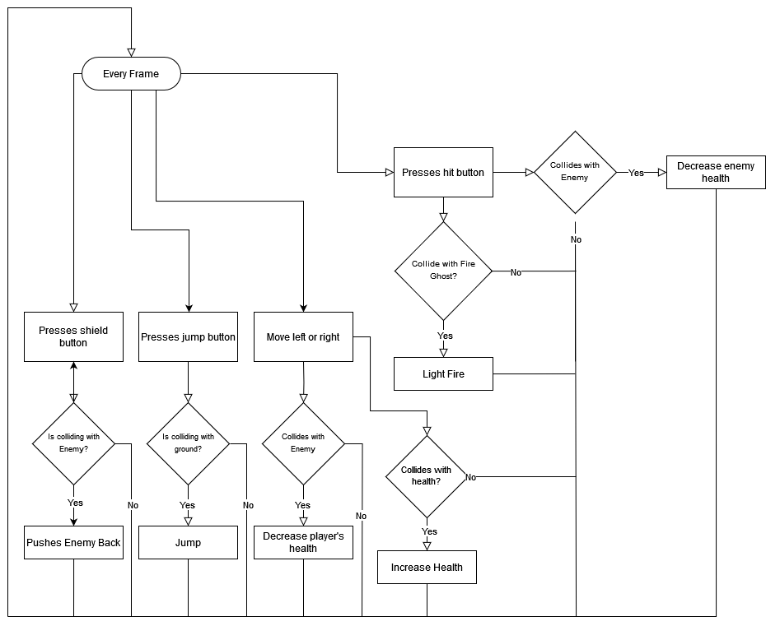

Figure 2: Points Gathered Flowchart

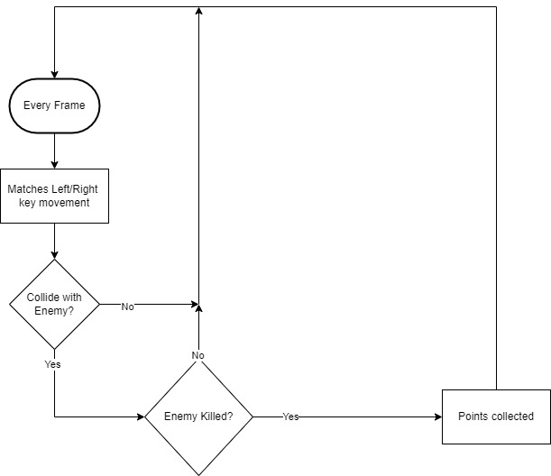

Figure 3: Items Collected Flowchart

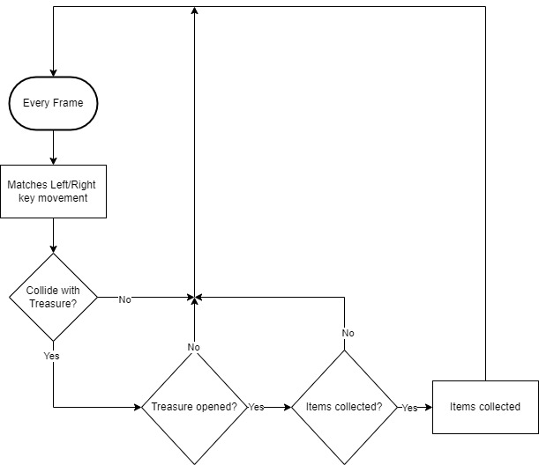

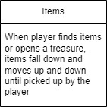 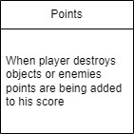

Figure 4: Spike Chaser Flowchart

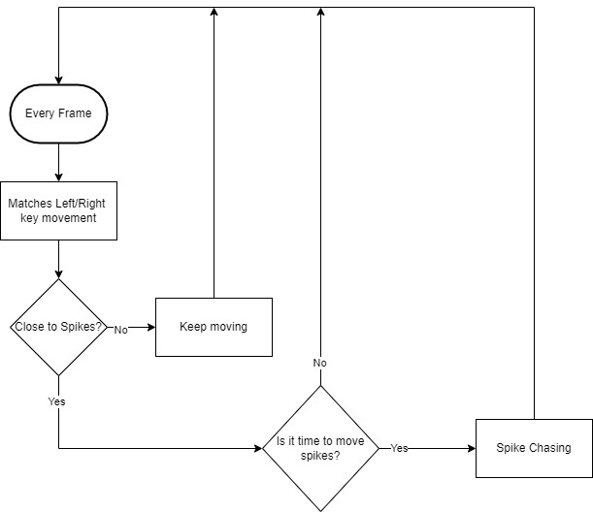

Figure 5: Spike Ball Flowchart Figure 6: Enemy (Rouge, Mascara, Ghost Pin) Flowchart

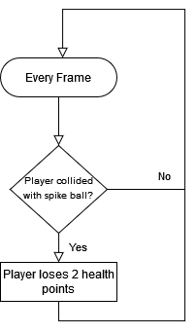 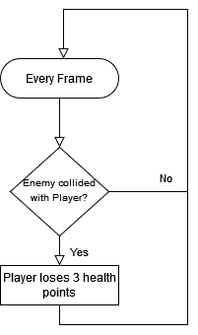

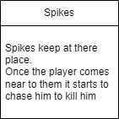 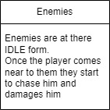

Figure 7: Items Flowchart 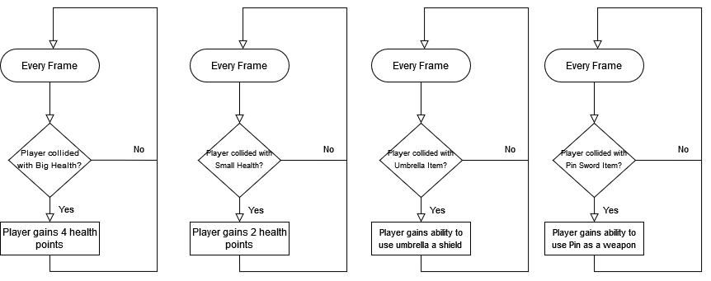

**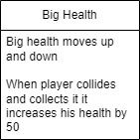 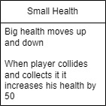 *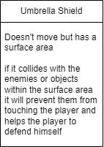 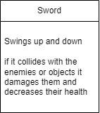***

Figure 8: Fall Weapon Flowchart Figure 9: Falling Bridge Flowchart

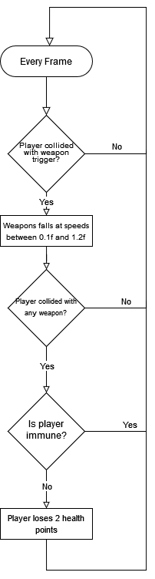 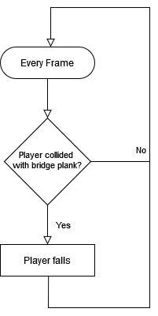

Figure 10: Vases Flowchart Figure 11: Ground spike Flowchart

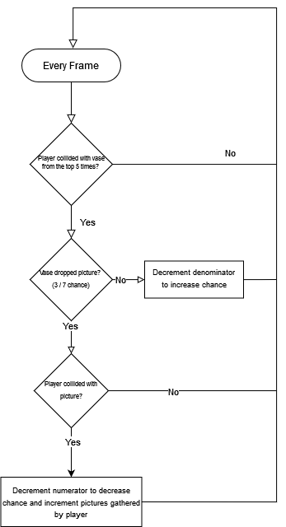 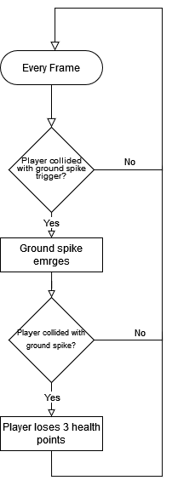

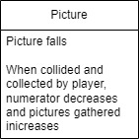 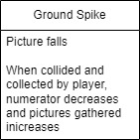

* + 1. **Challenges:**

Spike Ball Fire cat Fire Ghost

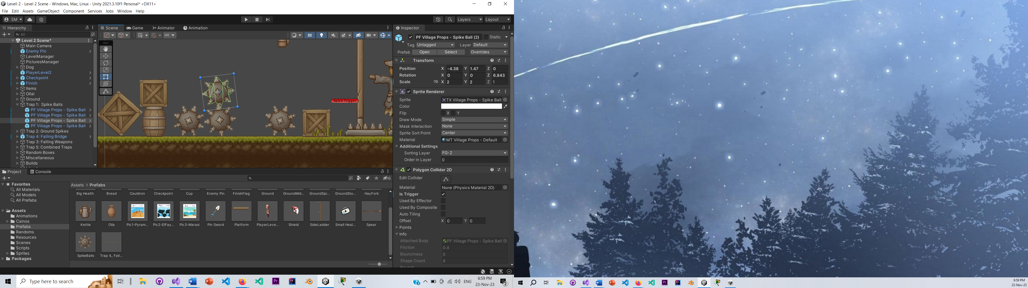 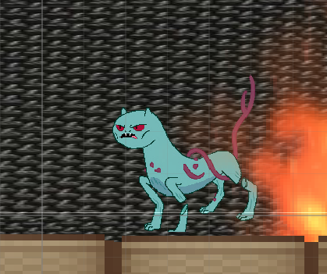 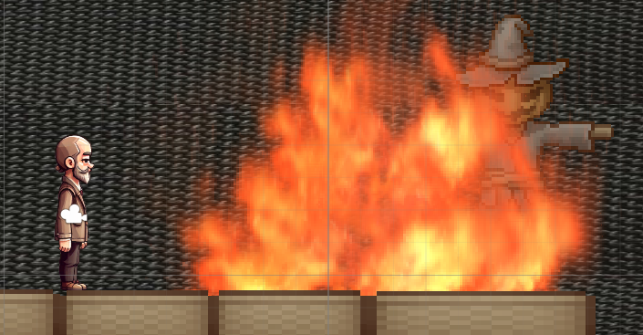

Falling bridge Mascara Rouge

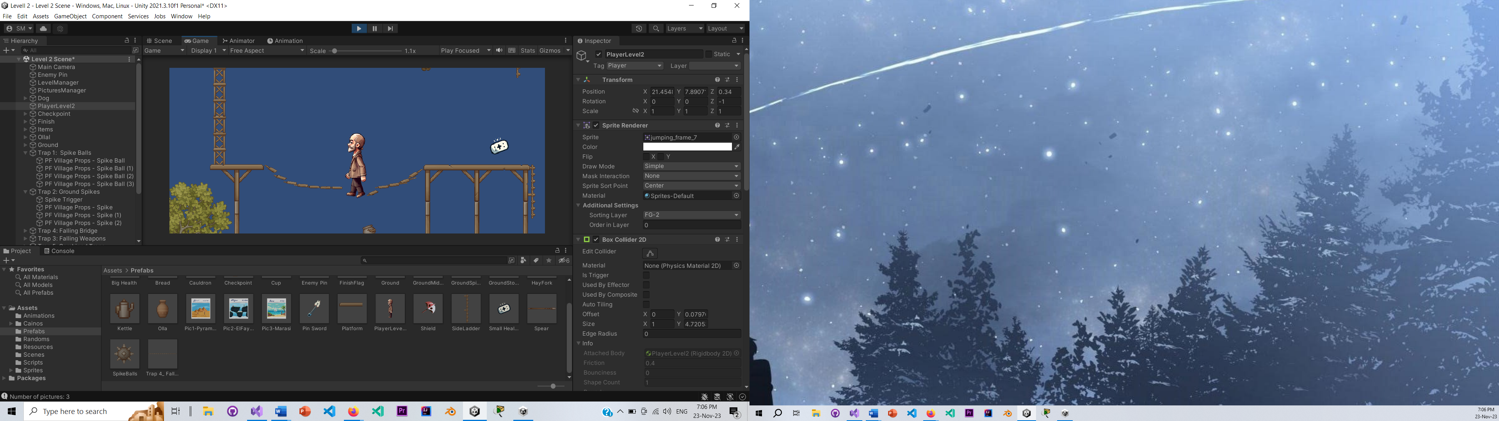 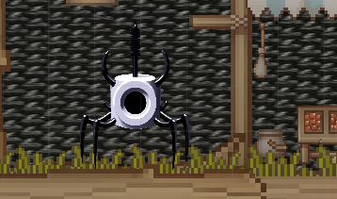 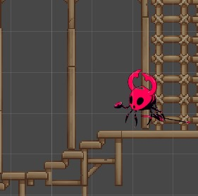

Ghost Pin Bridge Ground Spike

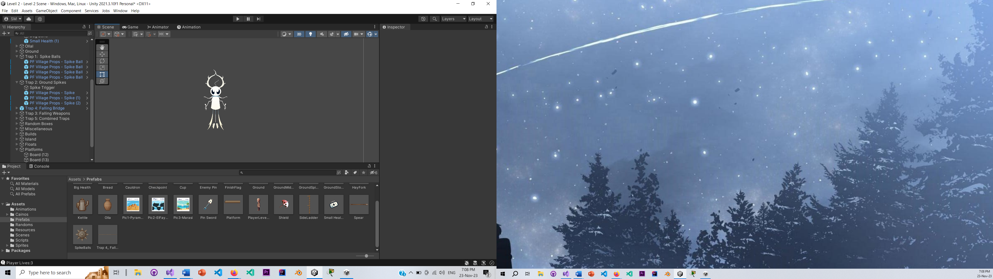 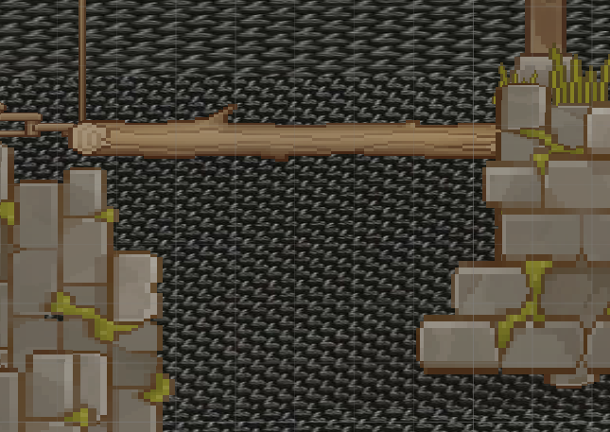 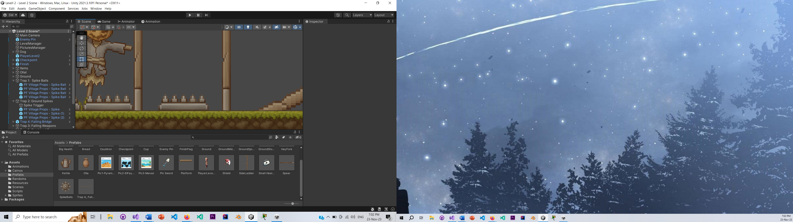

Weapons Falling

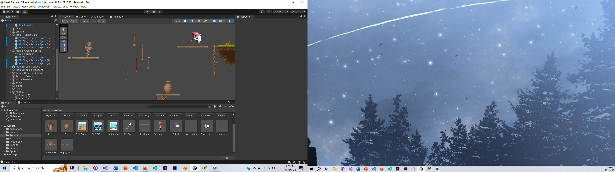

* + 1. **Resources**

   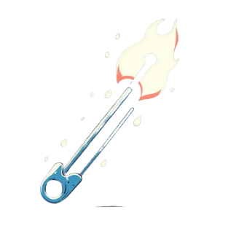

(1) (2) (3) (4)

1. Big Health: when player collides with it, it adds 4 points to the player’s overall health.

2. Small Health: when player collides with it, it adds 2 points to the player’s overall health.

3. Umbrella is an item that shields the player from nearby monsters and works by pressing ‘S’ on the keyboard to activate the umbrella and pushes enemy away that may collide with it.

4. Safety Pin is a weapon used to attack enemies in some levels and works by pressing ‘I’ on the keyboard towards their direction and decrease their health by 3 points.

* + 1. **Player Mode Sketches**:

**Level 1:**

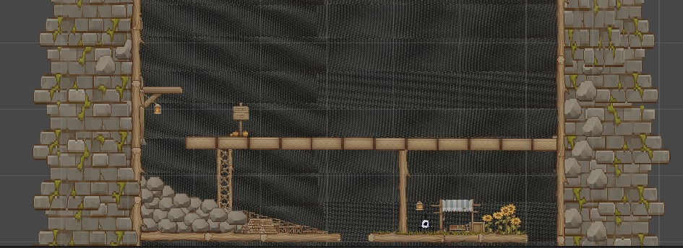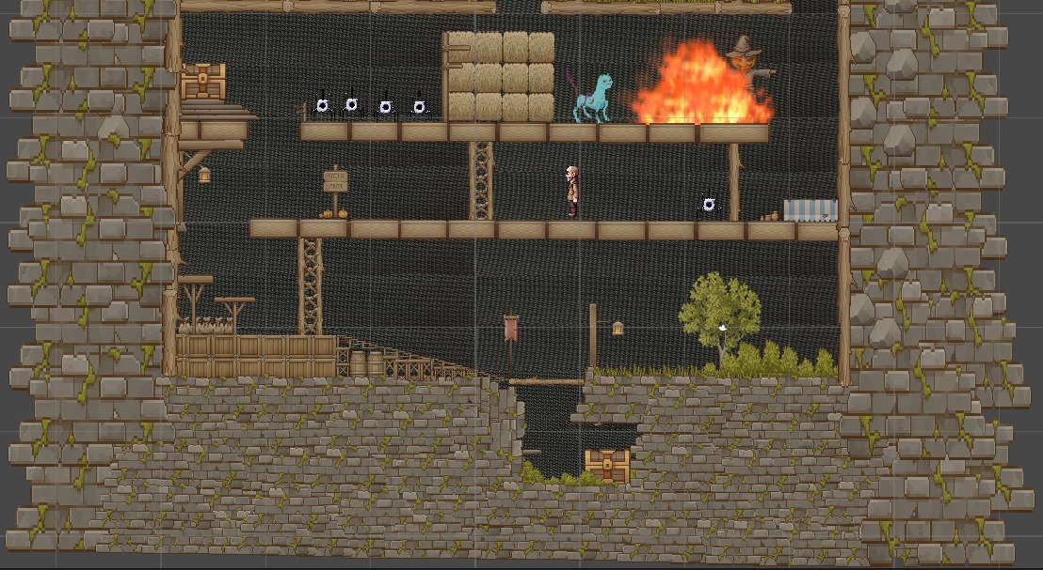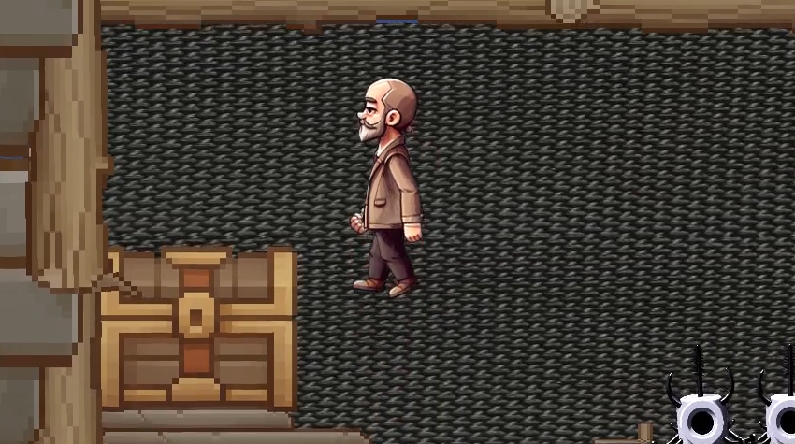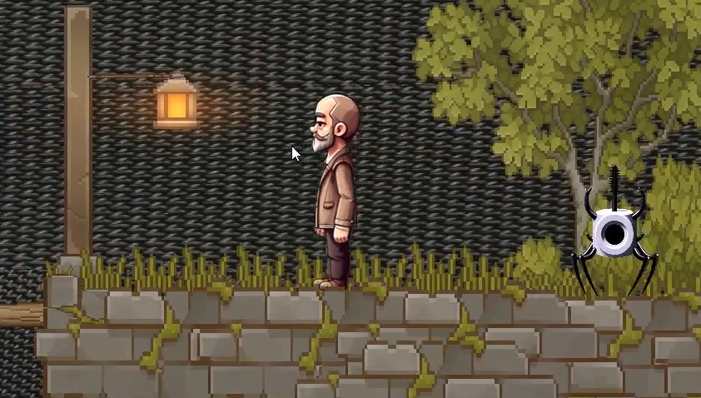 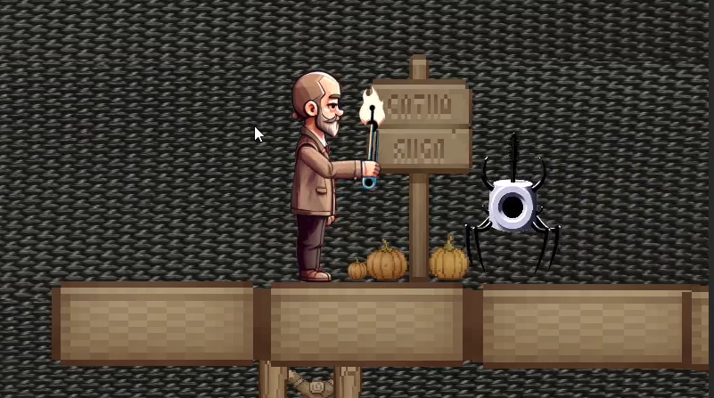

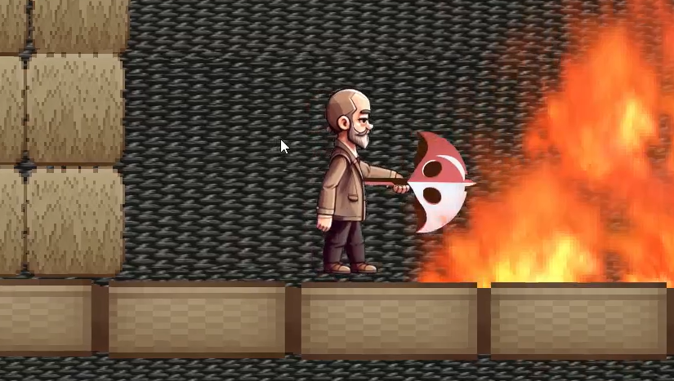

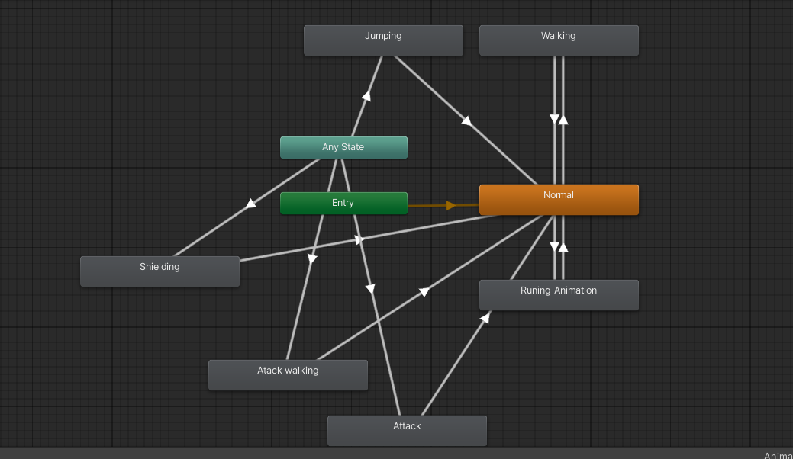

**Level 2:**

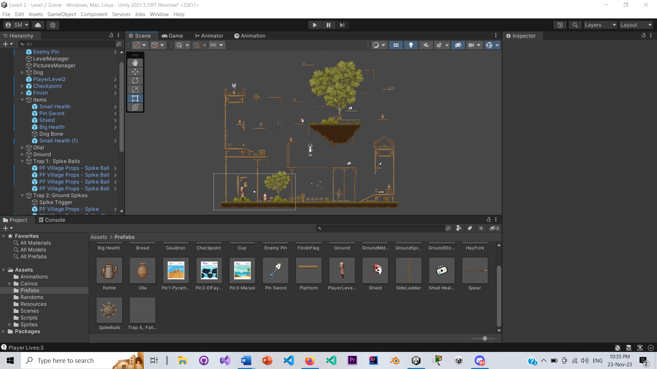

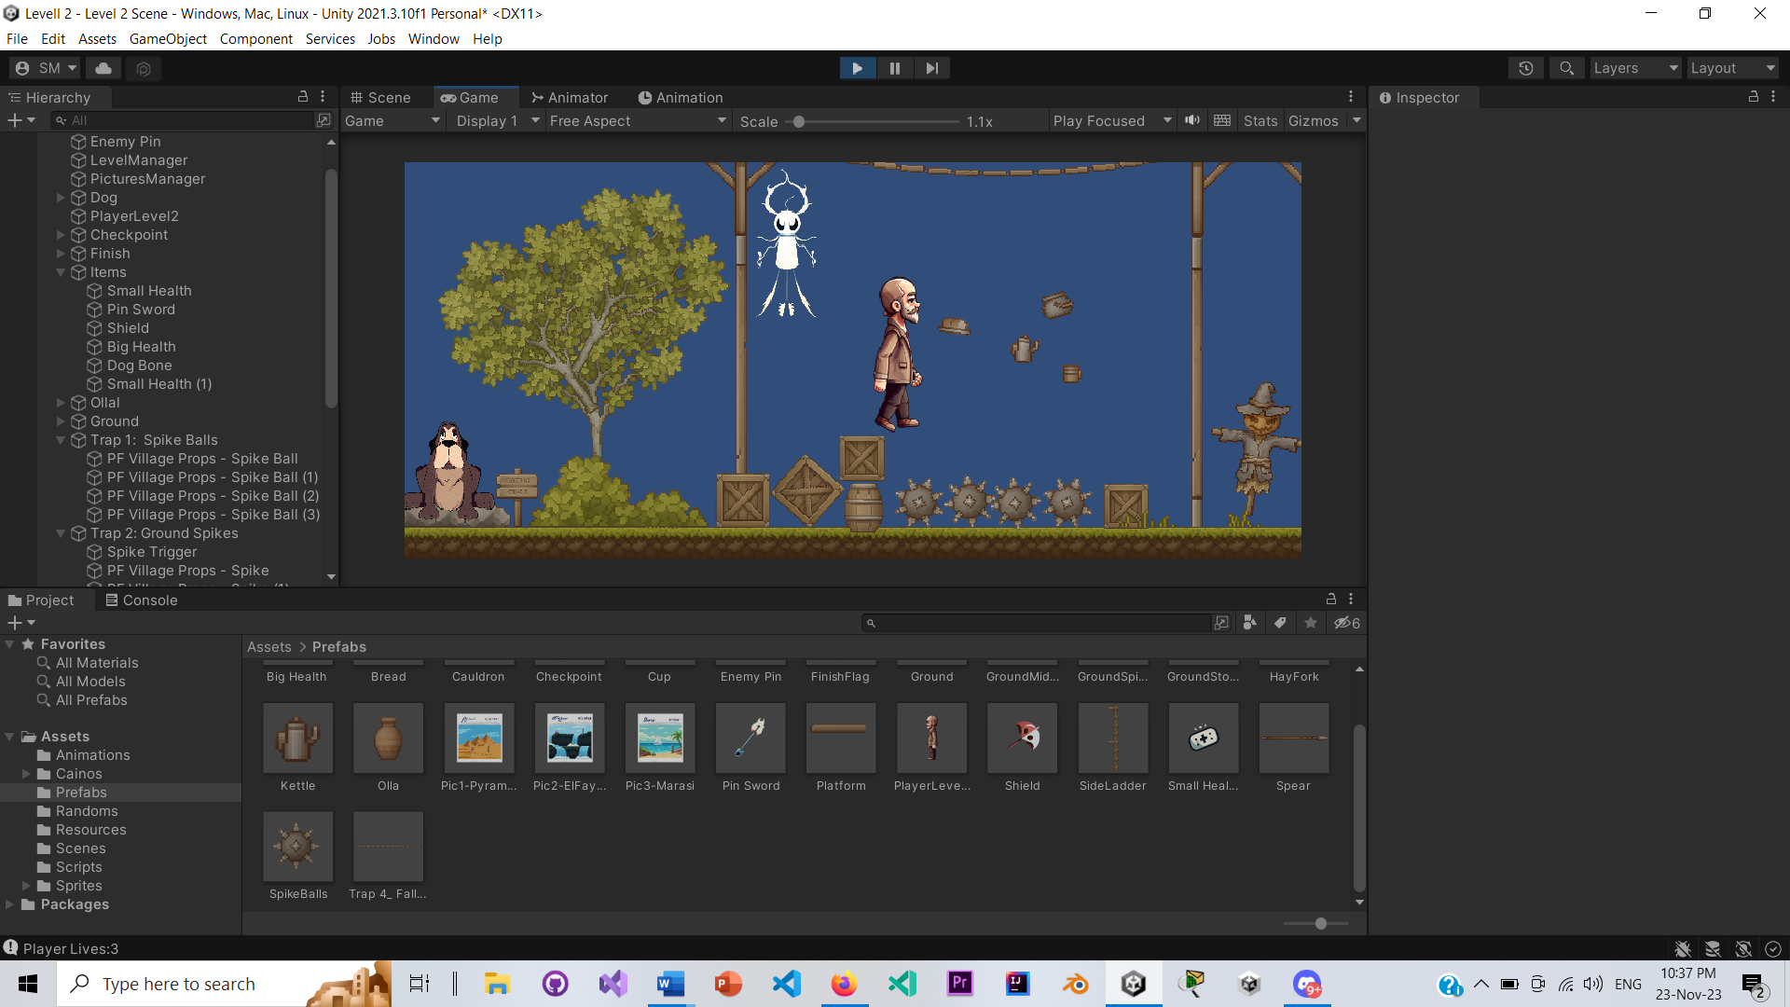

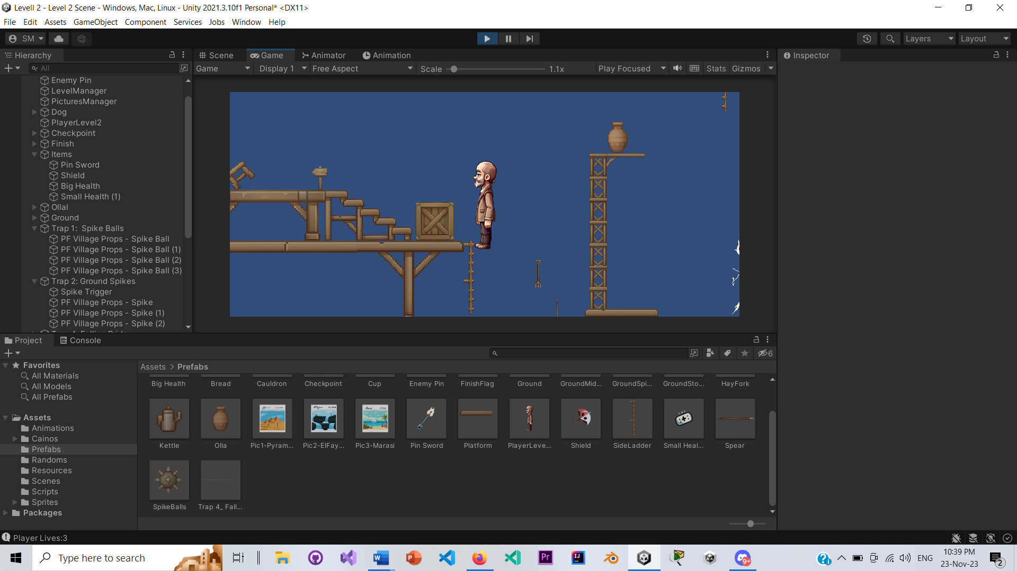 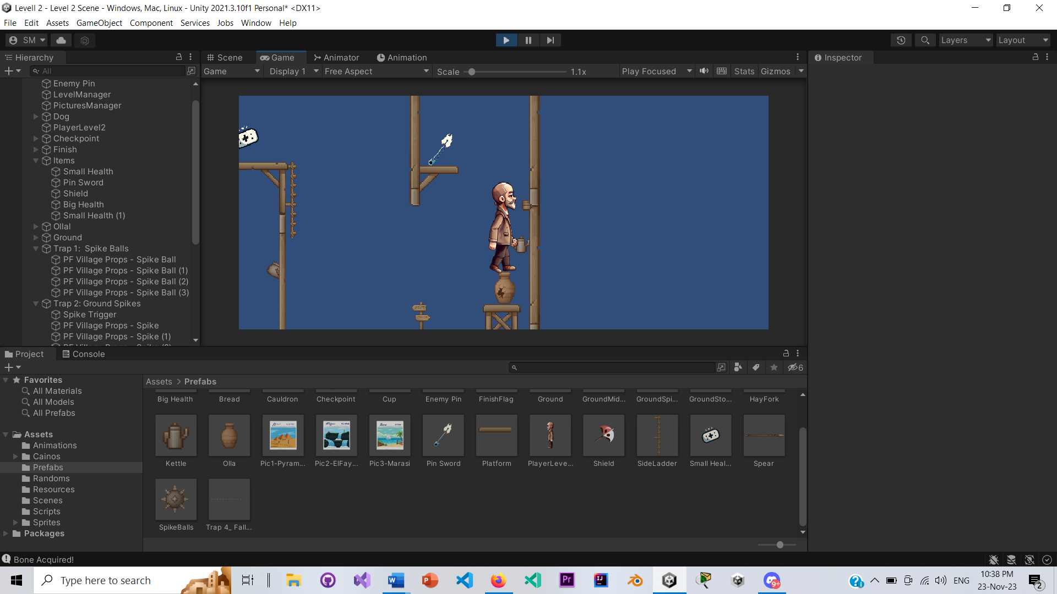

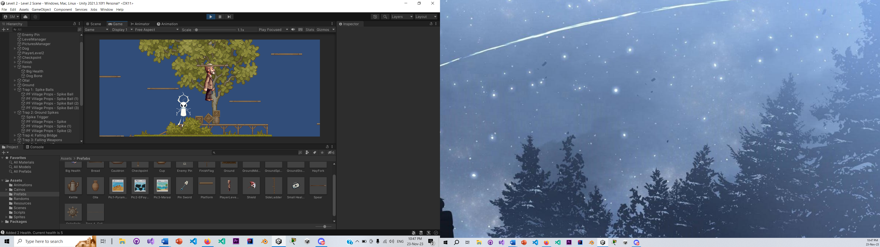

**Level 3:**

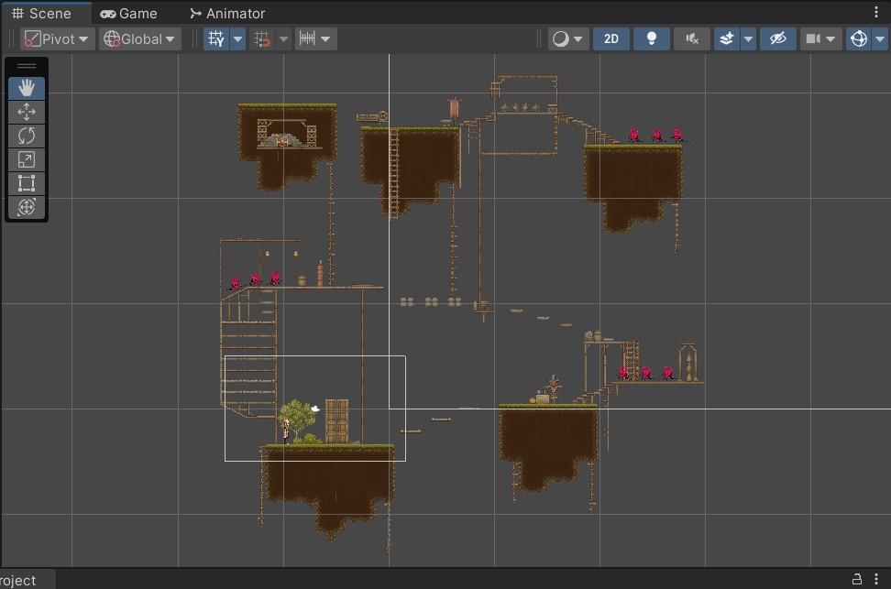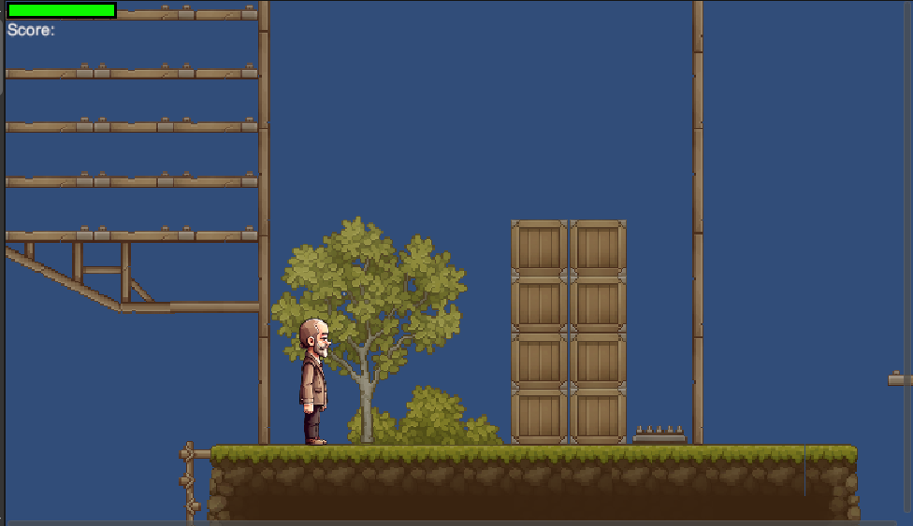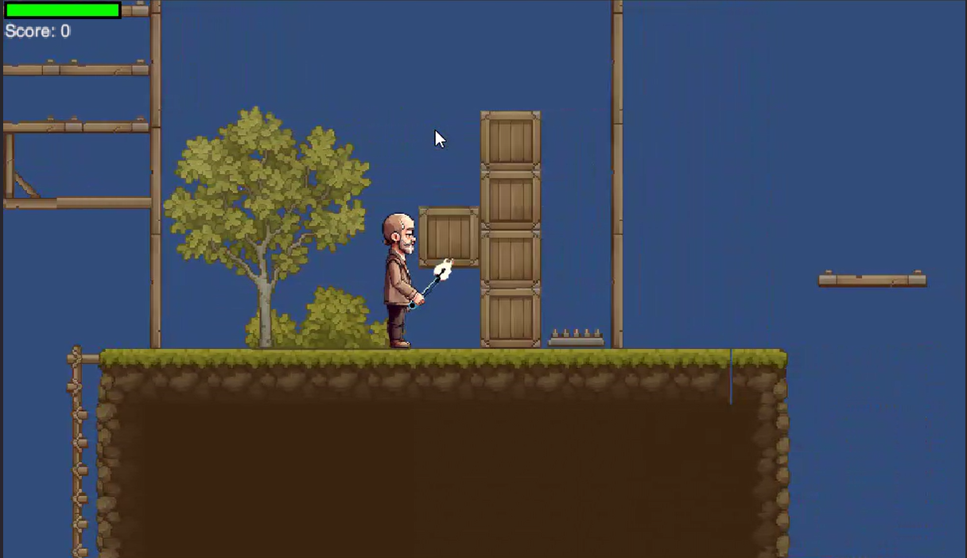

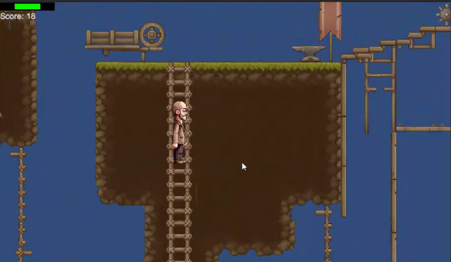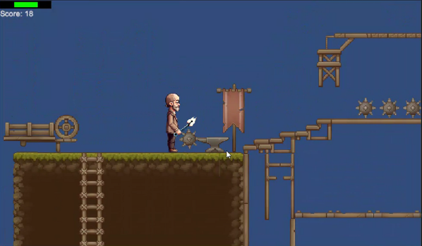

* + 1. **Audio**:

Background music: Epic adventure and Fantasy World

Sound effects from actors in movie “Taimor and Shafiqa”

* + 1. **Outcome**:

The game ends with Taimor defeating the final boss of the purse, his mother-in-law, and escaping from the world of the purse to return back to the real world where time barely passed between him entering and exiting the purse and instead of getting the thing is wife asked him to bring back, Taimor brings back the photo album and their first love letter and tells her “Happy anniversary” which sends a shock to his wife whose entire attitude changes when she realizes he hadn’t forgotten. The usually grumpy couple end up, even for a little moment, happy for the night as they go through their photo album, letter and reminisce on the past.

1. **Dynamic Elements**
   1. The sequence of events that take place in the story.

**Level 1**

* The level starts with the player being attacked by mascara, aiming to kill them.
* The player escapes and encounters a dog that leads them to the boxes they're seeking.
* While searching for these boxes, the player faces multiple enemies that cannot all be defeated at once.
* To tackle the enemies, the player fights them individually and then sets a fire to deal with the remaining foes.
* As the fire grows too large to extinguish, the player navigates to the second row to use a trampoline, enabling a long jump to the fourth row.
* On the third row, the player opens a box to uncover its contents.
* Moving to the fourth row, the player discovers a repository containing health drinks for a health boost.
* A sudden appearance of a new enemy confronts the player, forcing a decision to fight or escape.
* Finally, reaching the fifth row, the player encounters the wise statue, initiating a puzzle that requires using hints collected from the boxes to solve.
* Successfully solving the puzzle leads to advancement to level two.

**Level 2**

* The level begins with the dog withholding the level objective until the player retrieves his bone.
* Player obtains the bone and returns it to the dog.
* The dog gives the player his objective to break every Olla to get the missing three pictures from the album.
* Timor jumps on each Ollal five times until they break.
* There's an element of luck with the order through which he would find the pictures, so Timor traverses the level, going up and down, avoiding obstacles such as spike balls, ground spikes, falling bridges, and descending weapons.
* Throughout the journey, Timor is pursued by Ghost Pin as he attempts to gather all the missing photos.
* Timor gathers all three images and ascends the tree where he first proposed to his wife.
* Timor reaches the finish flag at the top of the tree, progressing to the next level of the purse.

**Level 3**

* The primary goal is to reach the letter located at the end of the level.
* Multiple obstacles block the player's path, hindering progress towards the letter.
* To unlock the path towards the letter, the player must amass points.
* Points are obtained by defeating enemies and destroying obstructive objects.
* Numerous enemies pose a threat, attempting to impede the player's progress.
* Combat skills are essential for survival and point accumulation.
* Acrobatic skills such as climbing are crucial as they are the only means to reach the letter.
* The level demands the utilization of these skills for progression.
* Players must strategize and balance combat, obstacle destruction, and acrobatic maneuvers.
* Upon accumulating the required points, a door leading to the treasure containing the letter will unlock.
* Accessing this treasure signifies successful completion of the level.

**Level 4**

* Taimor confronts his mother-in-law in the same location where marital problems started.
* Fights her along with her minions as he avoids the throwable items
* Runs to be protected by Metwaly’s shield.
* Successfully defeats her and earns the zipper to be free.
* Metwaly guides him through dark house until he reaches the end.
* Emerges from the underground ordeal to rejoin the outside world
  1. Behavior and relationships

**Level 1**

Throughout Level 1 the player starts to face many interactive objects that the player can interact with such as the mascara that the player should fight, weapons on the ground to be picked from the player, health drinks that the player can pick from the ground in order to increase its health, boxes that the player can open and close in order to get its components that contain the hints, fire ghost that the player can light fire beside in order to burn the enemies, dog that the player will speak with in order to get hints about the location of boxes and the wise status that the player will submit the puzzle answer to.

**Level 2**

Throughout level 3, there are various dynamic interactions between the player and the dog, Metwaly, where the dog insists on the player searching for his missing bone to reveal the level's objective. In pursuit of the objective, the player interacts with various obstacles, including spike balls, ground spikes, falling bridge and falling weapons that all could harm him within range. In order for the player to finish his objective of finding the missing photos from the album, he must jump five times on randomly scattered vases across the level and gather the missing photos. Throughout this whole journey, Ghost Pin is following the enemy all around the level and deals have his health in damage to the player upon contact, which could be mitigated by the player colliding with health items to replenish his health.

**Level 3**

Throughout Level 3, the Player faces multiple uncontrolled objects that make it harder for him to reach the letter that is going to make his escape to prevent that, he then starts to look for weapons in order to destroy these objects that stop him from reaching his main goal of collecting the letter. In addition, the player needs to keep balance in the level because if he falls, he may not reach his destination and cause his death. There are also some items in the game that he destroys In order to collect points for him to escape the level. On top of that, because all places are far apart and hard to reach the player must go through the ladders and climb it for him to transfer between one island to another.

**Level 4**

Lastly, level four presents the last challenge of the whole game, the mother-in-law. The player walks down a long corridor, surrounded with pictures and memories of his old life when he suddenly is met with items being thrown at him from the other side. He finds his mother-in-law along with other minions flooding towards him. The player can only interact with Metwaly the dog, who provides an internal shield and pushes the enemies and items back towards the other direction and guides him through the dark house until he reaches the zipper that breaks the curse of the purse.

* 1. The objectives and the details of what happens in each level.

**Level 1**

The level starts with the mascara that starts to chaise the player to kill him, the player starts to escape till suddenly find the dog that starts to guide the player to the location of boxes that the player wants to get its contents, the player starts to search for those boxes and while searching the player will face a lot of enemies, the player cannot fight all so have to think to find a way to destroy the enemies so the player starts to fight the individuals enemies and then light fire to burn other enemies, so after lighting fire the player will not be able to extinguish the fire because its huge fire so the player have to think to find a way to reach the box location without be close to the fire, so the player moves to the second row to use the trampoline to make him take a long jump to reach the fourth row directly then the player moves to the third row to open the box and read its contents, the player starts to moves to the fourth row to repository contains the health drinks to boost its health the suddenly the player will find a new enemy that trying to kill the player, so the player has to kill him or escape, finally the player reach the fifth row to find the wise statue. The wise statue starts to give the player a puzzle that the player must think to solve by using the hints that he collected later from the boxes so the player starts to solve, if he answers the puzzle correctly the player will pass to level two, if not he will take a hit for the wise statue that will kill him.

**Level 2**

The level begins with the dog refusing to give the player the objective of the level until he gets him his rightful bone. The player goes over spike traps and if he has a fast reaction time won't fall for spikes emerging from the ground. The player gets the bone and goes back to the dog to give it to him. The dog drops some lore into the story by talking about how "Ollet 7obena" was the among the first items they got for their home when they were newlywed. He explains that that album photo has been missing three pictures from their endless anniversaries Timor and Shafiqa had and that the photos can be found randomly inside any of the Ollal of the level. To acquire the photos, Taimor has to jump on the Ollal 5 times until they break. If lucky he'd get all the photos after breaking the first 3 Ollals he meets. Chances are, Taimor will keep going up and down the level, avoiding spike balls, ground spikes, falling bridge and descending weapons all while being followed by Ghost Pin as he tries to gather all photos. Once gathered, he'll keep going up the tree where he first proposed to his wife until he reaches the finish flag to ascend unto the next level in the purse.

**Level 3**

In level 3, the player must go through multiple obstacles to complete the game. This includes defeating enemies in addition to solving puzzles by finding mysterious items in the level in order to escape this level.

Moreover, he needs to find his love letter from his wife in order to complete the task so that he needs to escape the purse in order to get free and return back to his wife. On top of that, the player also needs to face many enemies before getting to the letter.

And also, he cannot access the letter until he defeats all the enemies. For the player to know where the final letter is that will make his dream of escaping the purse, he will get a guide help from the dog that has been living with him and his wife throughout their whole marriage time.

Moreover, this guide provides helpful mysterious information that gives hints and valuable information for the player to find the letter that will save his life from being stuck at this monstrous purse.

**Level 4**

Upon completion, and as he thinks he has finally escaped, he is met with one last challenge. The person behind his grim marriage and start of the issue as a whole. He fights his mother-in-law and all the minions he fought along the way to reach her in the place where all the issues began, her house. He must defeat her and all of the minions to get the zipper that opens the purse and escape, finally freeing him from the curse of the purse.

* 1. **Cut scenes:**

**Cut scene 1**: once the user starts the game will watch the game rules and constraints that will help him to prevent any mistakes while playing the game, this set of rules and constraints will cover all topics related to game control and game boundaries, all these rules and constraints will be displayed in user’s screen one by one.

**Cut scene 2**: after the player starts moving a letter toward the second floor, he will meet the dog that will start to direct (guide) the player to the box's location, this will be displayed on the user’s screen as clear English script, it consists of a certain number of advice and tips that will guide player to the correct destination.

**Cut scene 3**: After collecting the love letter that he was desperate to find it, He the finally faces his mother-in-law. When he starts to face her, all memories from the marriage until this moment was playing through at the background reminding him of the memories in front of his mother-in-law. On top of that, He also remembers all the goods and the bads he spended with his wife and his mother-in-law. After that, his Mother-in-Law gave him wise advice for him that will help him throughout his rest of his personal and marriage life, then she gives him a very special gift that was sent from his loved wife.

* 1. Different ways for guiding the players or giving them hints, within the context of the story.

**Direct Guidance:**

* Instructions: The dog will give the player the objective of each level and hints at how he could achieve it.
* Pop-ups: In certain levels, pop-ups may appear as a result of the player reaching a certain point in the level, guiding him to the next steps to finishing the level.

**Indirect Guidance:**

* Visual Design Landmarks: Some levels will be big and it would be easy to get lost, as a result, huge landmarks such as giant tree islands with platforms around it could be used to guide the player towards the proper direction they need to go to.
* Audio Design: There will be levels that rely on audio to guide the player such as level two where the player will hear the breaking of vase when he collides with it, indicating that this feature/mechanic was purposefully put there to guide him towards the greater objective.